*A day as UX designer*



Prepared for John Lara Rojas

Fontys University of Applied Sciences

Experience Design

Prepared by Martin Staykov

09.09.2020

***Introduction***

Nowadays many companies spend a significant amount of their budget for researching and developing appealing and easy-to-use products for their customers. The big tech giants like the FAANG (Facebook, Amazon, Apple, Netflix, Google) have different UX teams who focus on designing their products to be more user-centered and simple but there are still many web applications and websites which we use in our daily life which could make us frustrated because of their user experience and design.

Personally, I admire the people behind good web UX as I have been developing my own websites and apps and know how hard it could be to make them engaging. I am going to provide two examples of good and two examples of bad user experience and explain why I think they fit the description.

***Good UX***

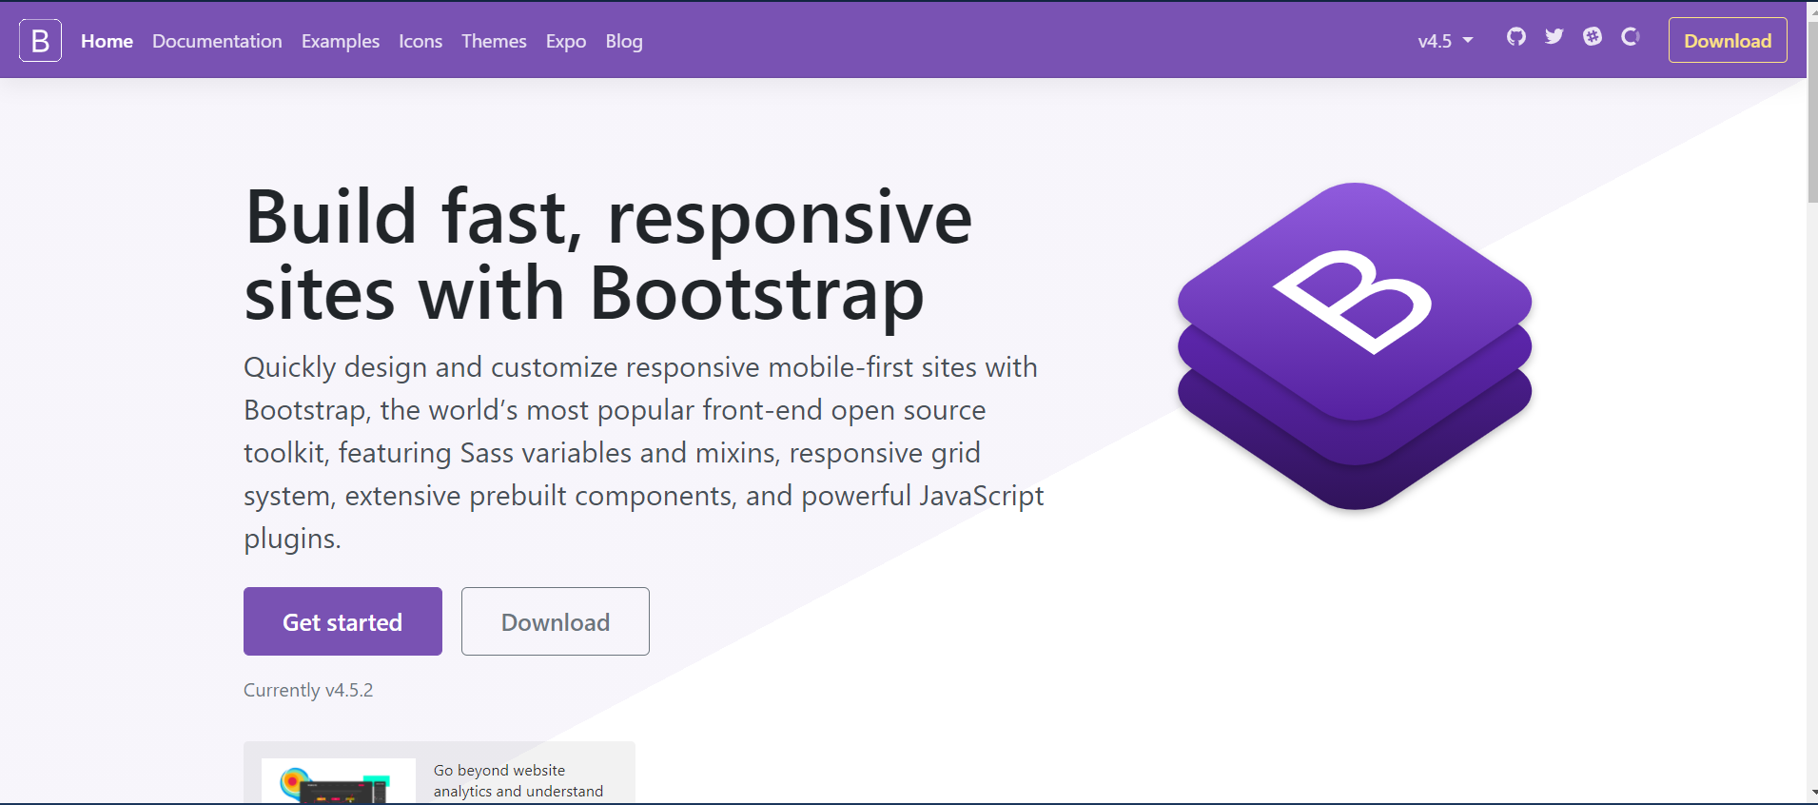***Bootstrap***

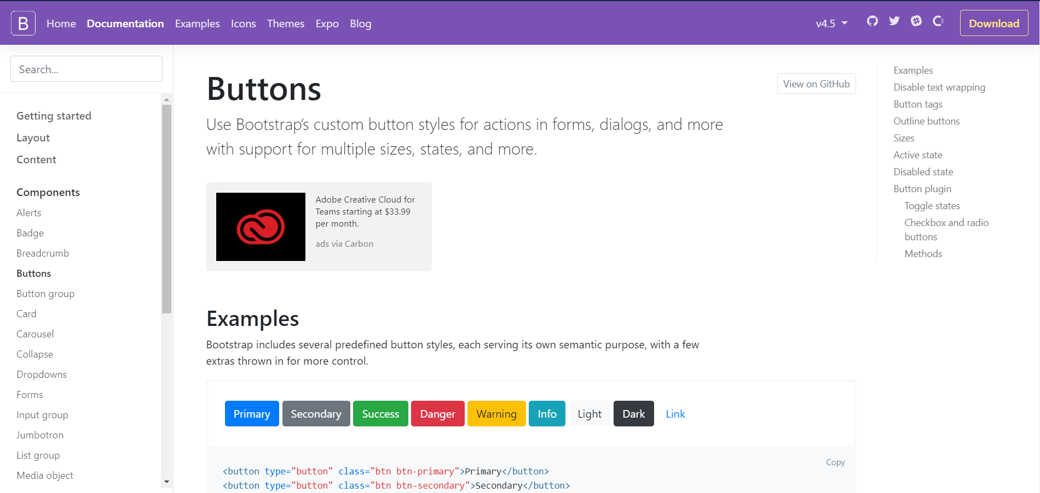I use Bootstrap to develop the front-end of my projects and I find it extremely easy to find the exact component I am looking for. The home page is simple and it provides information about how to get started with the framework but the documentation is where I spend most of my time when I am in the website. It is easy navigate through the pages as there is a main sidebar on the left which shows the content and the main components and whenever I view a page I can see all of its content on a different sidebar on the right.

I believe Bootstrap website is an example of a good UX because of its navigation efficiency and learnability. The examples of the components are easy to understand and have clear and simple design. The website demonstrates why Bootstrap is the world’s most popular front-end open source framework.

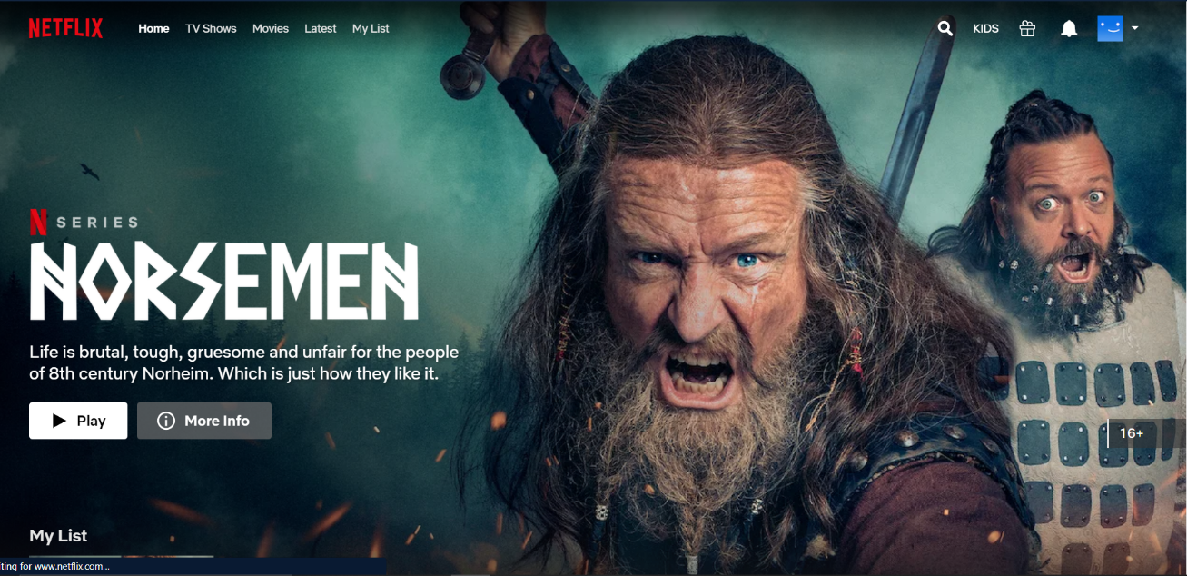***Netflix***

People who have watched movies or series from Netflix know how easy it is to browse around their website. This a company that puts a lot of effort into the UI and design so I am not going to talk about how good the quality is. I just want to emphasize two features that I think have a significant impact on Netflix users.

The first one is the colors used in the front-end which are white for text, black for background and the logo red. Personally, whenever I open Netflix I get into the mood for watching series or movies because of its template design.

The second thing I think Netflix has got right is the simplicity of their website. The only thing I can see when I open Netflix is movies and series and that makes the website engaging to users. I just pick something to watch and watch it and that is simplicity for me.

***Bad UX***

***Fontys Portal***



When I first logged in the Fontys Portal, I didn’t know what was going on and that’s normal but the problem is that the UI of the website is still very confusing to me. The reason for that I believe is the website navigation and the information shown everywhere.

Whenever I want to find something online the first thing I do is look at the navigation bar and go to pages I am interested in but in this website the only page I can visit is the English Stream. All the other pages are in Dutch and there is no option to translate a page and therefore is very hard for me to find anything I am looking for.

Another very important thing to comment on is the lack of responsive design and that also makes things hard and unappealing for me when I use my phone to open thе website.

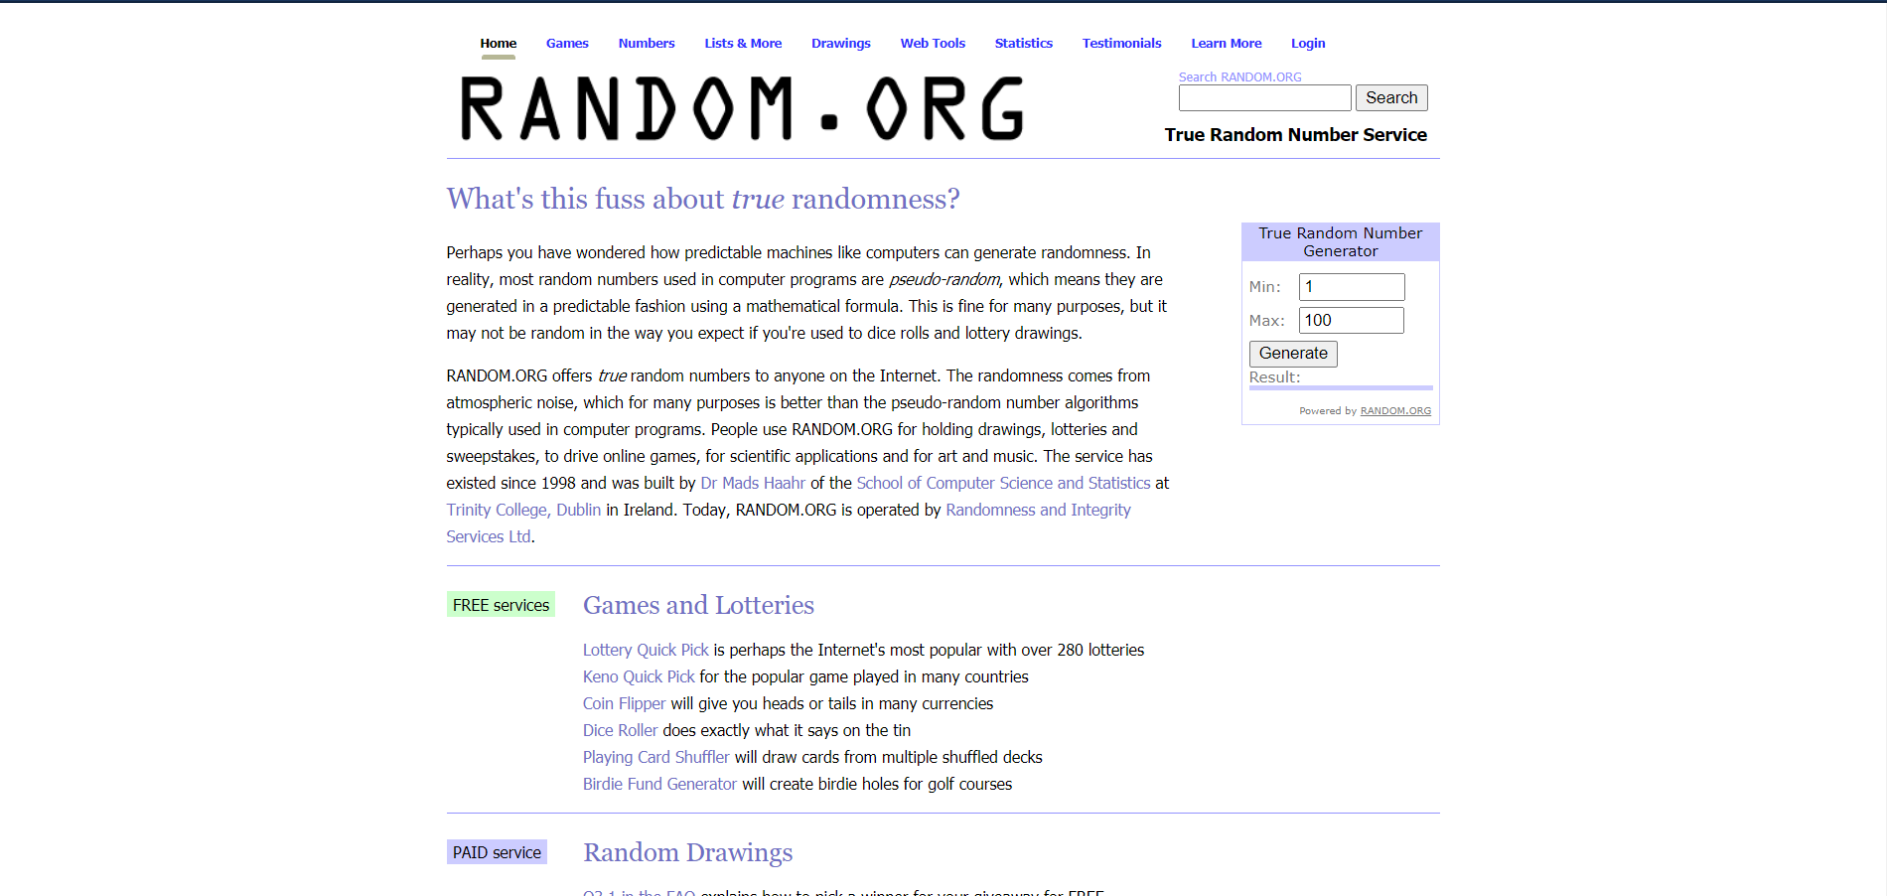***Random.org***

Random.org is a website we visit with my friends when we have to pick one of us to do something. The information in the website is useful and it is reliable but the main reason I chose it as a bad example is the lack of design development.

I have used this website for years and it has always had the same front-end and that is unattractive to me. The font size of the text is small, the text inputs too and there are some titles that change their color on hover but they are not actual links. I believe this website needs a lot of work done on the frontend as it also lacks responsive design and a modern look. The satisfaction of a user could be significantly increased if these features got improved.